Used Car Price Prediction Using Streamlit

1. Objective of the Application
The objective of this application is to predict the resale value of a used car based on its key attributes, such as car model, manufacturing year, kilometers driven, fuel type, seller type, transmission, and ownership history. A Machine Learning model using a Random Forest Regressor is trained on the CarDekho vehicle dataset and integrated with Streamlit to provide an interactive web interface. The user selects a car model from the dataset, enters the vehicle's specifications, and clicks the Predict button to obtain an accurate, data-driven estimated market price displayed in the standard Indian Lakhs format.

2. Problem Statement
The used car market is highly volatile, and determining a fair price relies on multiple interacting factors rather than a single metric. Buyers and sellers often struggle to objectively evaluate a vehicle's worth. The problem is to develop an advanced Machine Learning application that learns the non-linear relationships between a car's characteristics and its depreciation from the CarDekho dataset, predicting the expected resale price for a given vehicle profile. The application must make this prediction accessible through a user-friendly web interface and improve upon simpler models by handling multiple input features simultaneously — including the specific car model, fuel variant, ownership history, and seller category.

3. Description of Inputs and Outputs
Inputs
The application accepts the following features through Streamlit input widgets:
Input | Widget Type | Description
Car Model | Searchable Dropdown | Selects the specific car model from 1,491 unique vehicles in the CarDekho dataset (e.g., Tata Nexon 1.2 Revotron XM, Maruti Wagon R LXI Minor)
Year of Manufacture | Slider (2000–2024) | Represents the car's manufacturing year, used to determine vehicle age
Kilometers Driven | Number Input (0–5,00,000) | Captures the total distance the car has been driven in kilometers
Fuel Type | Dropdown | Type of fuel — Petrol, Diesel, CNG, LPG, or Electric
Seller Type | Dropdown | Category of seller — Individual, Dealer, or Trustmark Dealer
Transmission | Dropdown | Gearbox type — Manual or Automatic
Owner | Dropdown | Ownership history — First Owner, Second Owner, Third Owner, Fourth & Above Owner, or Test Drive Car
Outputs
After the user clicks the Predict Selling Price button, the trained model generates an Estimated Resale Value. The predicted monetary value is displayed prominently on the Streamlit page in the standard Indian Lakhs format (₹ X.XX Lakhs), along with the equivalent value in INR.

4. Explanation of How Machine Learning is Used
The project utilizes the CarDekho Used Car Dataset (CarDekhoCarDetails.csv) containing 4,341 historical used car sale records, mapping features like car name, year, kilometers driven, fuel type, seller type, transmission, and ownership history to the final sale price in INR. This multi-feature approach enhances prediction accuracy over single-variable models by capturing the complex interactions between different vehicle attributes.
The architecture is divided into three distinct operational files to separate model training, prediction logic, and the user interface:
Model Training (train.py)
This script loads and processes the CarDekho dataset. It performs the following steps:
- Feature Selection — Selects 7 input features: name, year, km_driven, fuel, seller_type, transmission, and owner, with selling_price as the target variable.
- Label Encoding — Encodes all categorical variables (car name, fuel type, seller type, transmission, owner) into numerical values using sklearn.preprocessing.LabelEncoder. Each encoder is saved individually for use during prediction.
- Train-Test Split — Splits the data into 80% training and 20% testing sets using train_test_split with a fixed random state for reproducibility.
- Model Training — Trains a RandomForestRegressor with 100 decision trees (n_estimators=100). The algorithm builds multiple decision trees to learn how age, mileage, and ownership history impact different car models uniquely.
- Model Evaluation — Evaluates model performance using the R² (coefficient of determination) score on the test set.
- Artifact Export — Saves the trained model as car_price_model.pkl, all five label encoders as individual .pkl files, and a sorted list of 1,491 unique car names as car_names.pkl using joblib.dump().
Prediction Logic (predict.py)
This file loads the saved .pkl model and all five label encoders using joblib.load(). It provides a dedicated get_prediction() function that:
- Accepts raw user inputs (car name, year, km driven, fuel type, seller type, transmission, owner).
- Encodes each categorical input using the corresponding fitted label encoder.
- Constructs a properly formatted Pandas DataFrame matching the training feature order.
- Passes the encoded input to the model's predict() method and returns the predicted selling price.
User Interface (app.py)
The Streamlit application provides the interactive web dashboard:
- Loads the list of car names from car_names.pkl to populate a searchable dropdown menu.
- Collects the user's vehicle details through form widgets organized in a two-column layout.
- When the Predict Selling Price button is clicked, it passes all inputs to the get_prediction() function in predict.py.
- The resulting predicted price is displayed in the Indian Lakhs format (₹ X.XX Lakhs) with the raw INR value shown below.

5. Project File Structure
UsedCarPricePrediction/
├── CarDekhoCarDetails.csv # Source dataset (4,341 records, 8 columns)
├── train.py # Model training and artifact export script
├── predict.py # Prediction logic with encoder handling
├── app.py # Streamlit web interface
├── requirements.txt # Python dependencies
├── car_price_model.pkl # Trained Random Forest model (generated)
├── name_encoder.pkl # Car name label encoder (generated)
├── fuel_encoder.pkl # Fuel type label encoder (generated)
├── seller_type_encoder.pkl # Seller type label encoder (generated)
├── transmission_encoder.pkl # Transmission label encoder (generated)
├── owner_encoder.pkl # Owner label encoder (generated)
└── car_names.pkl # Sorted list of 1,491 unique car names (generated)

6. Dataset Description
Source: CarDekho Used Car Details Dataset
Column | Data Type | Description
name | String | Full car model name (e.g., Maruti Wagon R LXI Minor)
year | Integer | Year of manufacture (2000–2020)
selling_price | Integer | Resale price in INR (target variable)
km_driven | Integer | Total kilometers driven
fuel | String | Fuel type — Petrol, Diesel, CNG, LPG, Electric
seller_type | String | Seller category — Individual, Dealer, Trustmark Dealer
transmission | String | Gearbox type — Manual, Automatic
owner | String | Ownership history — First Owner through Fourth & Above Owner, Test Drive Car

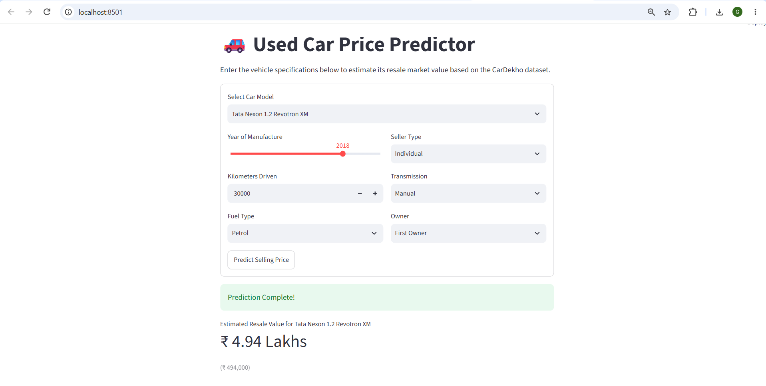
7.Screenshot of the deployed application
8. Links
Streamlit Deployment Link:

GitHub Link:

